

Tribhuvan University

Faculty of Humanities and Social Sciences

**News Portal**

**A PROJECT REPORT**

**Submitted to**

**Department of Computer Application Asian College of Higher Studies**

*In partial fulfillment of the requirements for the Bachelors in Computer Application*

Submitted by

Subin Dhakal(190627)

Under the Supervision of

Pranaya Nakarmi



**Tribhuvan University**

**Faculty of Humanities and Social Sciences  
Asian College of Higher Studies**

**Supervisor’s Recommendation**

I hereby recommend that this project prepared by Subin Dhakal entitled “News Portal” in partial fulfillment of the requirements for the degree of Bachelor of Computer Application is recommended for the final evaluation.

………………………..

Pranaya Nakarmi

Lecturer

Humanities and social science

Asian College of Higher Studies



**Tribhuvan University**

**Faculty of Humanities and Social Sciences  
Asian College of Higher Studies**

**LETTER OF APPROVAL**

This is to certify that this project prepared by Subin Dhakal entitled “Newsportal” in partial fulfillment of the requirements for the degree of Bachelor in Computer Application has been evaluated. In our opinion, it is satisfactory in the scope and quality as a project for the required degree.

|  |  |
| --- | --- |
| **……………………………………**  **SIGNATURE of Supervisor**  Pranaya Nakarmi  Asian College of Higher Studies  Ekantakuna, Lalitpur | **……………………………………**  **SIGNATURE of HOD/ Coordinator**  Mohan Maharjan  Asian College of Higher Studies  Ekantakuna, Lalitpur |
| **……………………………………**  **SIGNATURE of Internal Examiner**  **Internal Examiner** | **……………………………………**  **SIGNATURE of External Examiner**  **Eternal Examiner** |

# Abstract

The project ‘News portal’ is a desktop-based application that provide user interface to read the latest news. The aim of this project is to provide a suitable and digital platform for providing recent news in fast form. It is aimed towards time saving. The user can read the interesting news easily. However, these models do not meet all of the requirements needed for a good system. It is important to note that while this project represents a significant step forward in providing a digital solution for accessing news, it is not without its limitations. As with any technology, there are inherent challenges to address, such as ensuring the accuracy and credibility of the news sources, dealing with potential biases, and creating an intuitive user interface that meets the diverse needs and preferences of our users.

# Acknowledgement

I take the opportunity to thank every teacher and faculty member who helped and supported me on this project “Newsportal”. Thanks to Mr. Pranaya Nakarmi, my supervisor to provide the proper direction and advice at the critical juncture and to show me right path to learn a lot of new things, and we are grateful to our professors for that. I express my heartfelt gratitude to my friends and faculty member for their support and their knowledge and encouragement.

Project member

Subin Dhakal

Table of Contents

Abstract i

Acknowledgement ii

Figure 1: Use Case Diagram of News Portal 5

# Chapter 1: Introduction

## 1.1. Introduction

A news portal is a website or online platform dedicated to providing news and information on various topics to its users. It serves as a centralized hub where visitors can access and stay informed about current events, breaking news, feature stories, opinion pieces, and other relevant content.

News portals typically cover a wide range of subjects, including politics, business, technology, entertainment, sports, health, science, and more. They may focus on local, national, or international news, catering to specific regions or a global audience.

In this proposal, I will outline a plan to develop a News portal using a php, js, html, css. The project proposes to develop a website that allows user to get the news in fastest way possible.

## 1.2. Problem Statement

The problem with traditional way of getting news i.e., in newspapers and magazines are error-prone and repeated. Reading the news on paper and magazines creates unnecessary junk. The proposed project is to develop a website in php that provides an unlimited number of news with a proper user interface. Reading news on paper are time-consuming but in the proposed project user can track their time along with progress.

## 1.3 Objectives

The objective of this project is to develop a fully functional news portal that provides user with an unlimited number of news, and a user-friendly interface. The primary objectives of the project are listed below:

* To provide a reliable and up-to-date source of news.
* To enhance user experience and engagement.
* To implement healthy content management and publishing systems.
* To provide Comprehensive Coverage.

## 1.4 Scope and Limitation

### 1.4.1 Scope

The News portal website is designed to provide an interactive platform for getting fastest news. The scope of the application includes the following:

* News Coverage
* Geographic Coverage
* Content Formats
* Target Audience
* Multi-Language Support
* Collaborations and Partnerships

### 1.4.2 Limitation

* Credibility and Trust:
* Bias and Objectivity
* Information Overload
* Lack of Context and Depth

## 1.5 Report Organization

**Chapter 1:**

It includes the introduction of the project where problem statement, objective of the project along with the scopes and limitations of the project are listed which will provide a general concept of the project to the reader.

**Chapter 2:**

It includes background study and literature review of a similar project and concepts of the current project.

**Chapter 3:**

It contains the workings of the project including feasibility analysis, functional and nonfunctional analysis along with the schema and architectural design and the data and process modeling diagrams.

**Chapter 4:**

It includes the testing and implementation phase of the project i.e. it includes designing of test cases to check if the system and its components work as intended during development. It also contains tools that were used in the construction of the project.

**Chapter 5:**

It includes the testing and implementation phase of the project i.e. it includes designing of test cases to check if the system and its components work as intended during development. It also contains tools that were used in the construction of the project.

# Chapter 2: Background Study and Literature Review

## 2.1 Background Study

News portal websites originated with the widespread adoption of the internet and digital technologies. In the mid-1990s, news organizations began launching their own websites to publish news articles online, marking the early stages of online news dissemination (Zhou, 2003). As the internet evolved, news aggregation services and portals emerged to curate and consolidate news content from various sources, providing a centralized platform for users to access news conveniently.

The rise of smartphones and mobile devices prompted the development of responsive design, ensuring news portals were optimized for mobile browsing. Social media integration further transformed the news landscape, enabling users to share articles and engage in discussions. Personalization features, driven by data analytics, allowed news portals to tailor content recommendations based on user preferences.

## 2.2 Literature Review

The objective of this literature review is to explore previous research and related work on news portal website. The review aims to identify different approaches, technique, and optimizations utilized by researchers in news portal website.

The research paper titled "The Drudge Report" by Matt Drudge in 1996 presents on manual curation and linking to noteworthy news articles. (Drudge Report, 2001) The authors highlight the widespread popularity. The emphasis was on selecting and organizing news articles based on editorial judgment and user relevance. As technology advanced, algorithms became more prominent in news portals for tasks like content recommendation, personalized news feeds, and data analytics. However, the specific algorithms used by these early news portals were not as complex or advanced as the algorithms employed in modern news recommendation systems

Yahoo! News, launched in 1996, was an early example of a comprehensive news portal that featured original content alongside aggregated news articles. Yahoo! employed a combination of human editors and algorithms to curate and organize news content based on categories and user interests. (History of Yahoo!, 2023)

# Chapter 3: System Analysis and Design

## 3.1 System Analysis

System analysis is conducted for studying a system or its parts in order to identify its objectives. A problem-solving technique improves the system and ensures that all the components of the system work efficiently.

### 3.1.1 Requirement Analysis

Functional requirement defines a function of a system or its component. A function is described as a set of inputs, the behavior, and outputs. It may be calculations, technical details, data manipulation and processing and other specific functionality that define what a system is supposed to accomplish.

#### Functional Requirement

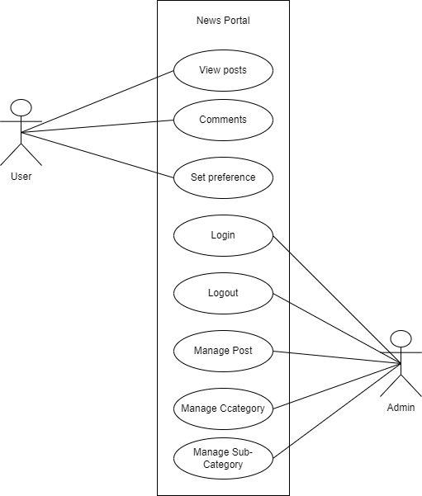

Figure 1: Use Case Diagram of News Portal

* Users will be able to view news.
* Users will be able to comment
* Users will be able to set preference.

#### Non-Functional Requirements

Non-functional requirement is a specification that describes the system’s operation capabilities and constraints that enhance its functionality. Some of the non-functional requirements are:

* Performance:

The app should provide a responsive user interface, with quick response times for user interactions. The app should be able to handle large number of user without significant performance degradation.

* Usability:

The app should have an intuitive and user-friendly interface, with clear instructions and easy navigation.

* Reliability:

The app should be stable and not crash or freeze during normal usage scenarios. The app should handle errors gracefully, providing informative error messages to users when necessary.

* Error Handling and Logging:

The app should provide appropriate error messages to users, indicating the nature of the error.

### 3.1.2 Feasibility Analysis

Under feasibility analysis we will be discussing about technical feasibility, operational feasibility and economic feasibility.

### i. Technical

The application is build-using IDE like VS code to perform the coding and MS SQL for database in the system. Therefore, we utilize the existing technologies to create the project, due to which there is less chance of technical hindrance while building the system.

### ii. Operational

The human resource needed for the operation of the system need to have basic knowledge in computer operating and need English language which is feasible to find. Hence, all the operational requirements are feasible hence, the project purposed is feasible.

### iii. Economic

Economic analysis of the project is carried out by comparing estimated cost required to develop the product and to integrate with the system. As, there is no requirement for any extra software or hardware in this system during the process of overall system development. We use open-source technologies to build the project. Due to these reasons, the overall cost of the project is not very high.

### 3.1.3. Data Modeling ER Diagram

### 3.1.4. Process Modelling DFD

Figure 2: Process-Modelling DFD

Here in the above figure, we can see the process modeling DFD of our system where the user is able to perform the operations provided by News portal system to the user. The user will be able to view, and comment on posts. User will be able to view posts provided by the system and managed by the admin. The user will be able to set preference of their choice. Admin will manage posts and category can view reviews and feedbacks given by the users.

## 3.2 System Design

## 3.2.1 Architectural Design

Figure 3: Architectural Design

Here the architecture design of the News Portal system, which has main page as home page. From home page user can view news and make comment on posts. User can also set preferences according to their need whereas admin can login from home page through login button, edit the post, category, and sub category of website.

### 3.2.2 Database Schema Design

Figure 4: Database Schema Design

The above shown figure represents schema diagram of our News portal where the relation between tables are shown clearly with their respective primary keys and foreign key relating to the other table and creating a relationship between the tables.

## 3.3 Algorithm Detail

Priority Scheduling is a CPU scheduling algorithm that assigns priorities to tasks based on their relative importance or urgency. The tasks with higher priorities are executed before tasks with lower priorities. This algorithm ensures that high-priority tasks are given precedence over lower-priority tasks, allowing critical tasks to be completed promptly.

In Priority Scheduling, each task is associated with a priority value, which can be assigned based on factors like task deadlines, importance, or user-defined criteria. The priority can be represented by an integer value, with a higher value indicating a higher priority (e.g., 1 being the highest priority).

# Chapter 4: Implementation and Testing

## 4.1. Implementation

### 4.1.1. Tools Used

* **CASE tools:** 
  + **VS code:** We used this tool for coding our project.
  + **XAMPP:** We used Apache & MySQL from this tool to run code and database (MySQL).
* **Programming languages:** 
  + **Php:** We have use php for writing this desktop-application.
  + **Java script:** JavaScript was used for client-side scripting and interactivity in the system.
  + **CSS:** CSS was utilized for styling and visual presentation of the system.
* **Database platform:** 
  + **MySQL:** MySQL is used for storing data. It is used as database.

## 4.2. Testing

### 4.2.1 Test Cases for Unit Testing

|  |  |  |  |
| --- | --- | --- | --- |
| Test Case | Test Data | Expected Outcome | Test Result |
| Login | Username:  Password: | Fill all the requirements | Pass |
| Username: useradmin  Password: admin123 | Character must be at least  8 characters | Pass |
| Username: useradmin  Password: admin123 | Username doesn’t match the filled Are. | Pass |

Table 1: Admin Login test of News Portal

### 4.2.2 Test Cases for System Testing

1. **Functional Testing:**

Verified that Admin can successfully register to use the app. Different scenarios is tested for validation purpose. No duplicate username is allowed.

1. **UI Testing:** UI is successfully checked. The buttons are used properly. The input to be filled in is responding as per requirement.

1. **Error Handling:** Messages are shown as per the error. The error of the system as well as user is handled well.

# Chapter 5: Conclusion and Future Recommendations

## 5.1 Conclusion

In conclusion, news portal website strives to be your ultimate source of timely and reliable information. We understand the importance of staying informed in today's fast-paced world. With a user-friendly interface, intuitive navigation, and a wide range of categories, we aim to cater to diverse interests and provide a seamless browsing experience. Whether you are seeking the latest updates on global events, in-depth analyses, thought-provoking opinion pieces, or heartwarming stories from around the world, our news portal has something for everyone.

## 5.2 Lesson learnt

During the development of the project, various software and reports were needed to be learnt. Creating a desktop-based web portal is a challenging and rewarding project that involves various technical and design considerations. Throughout the development process, several valuable lessons were learned that could guide future projects and enhance overall software development skills.

## 5.3 Future recommendation

In the rapidly evolving landscape of news and media, it is important for news portals to stay ahead of the curve to remain relevant and engaging for their audience.

* Personalized Content Delivery: Implement advanced algorithms and AI-driven systems to provide personalized news content to users based on their interests, reading history, and behavior. This can enhance user engagement and retention.
* Fact Checking and Verification: Develop robust fact-checking mechanisms to combat misinformation and fake news. Integrating AI tools to identify false information and providing transparent sources for news stories can enhance credibility.
* Localized and Hyper- Local News: While global news is essential, hyper-local news can also drive engagement. Cover neighborhood issues, local events, and community stories to connect with your immediate audience.
* Cultural and Diversity Coverage: Place emphasis on diverse voices and cultural representation in your reporting. Cover a wide range of perspectives and stories that resonate with different demographics.

# Appendices

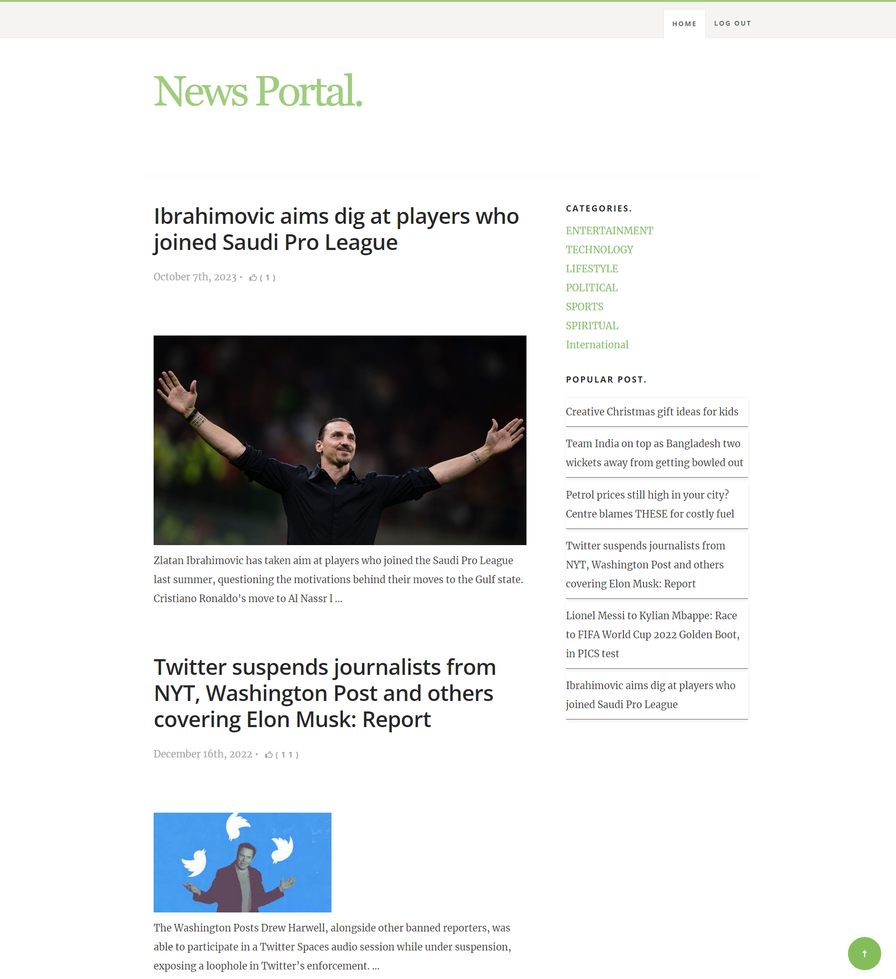

Figure 5: Home Page

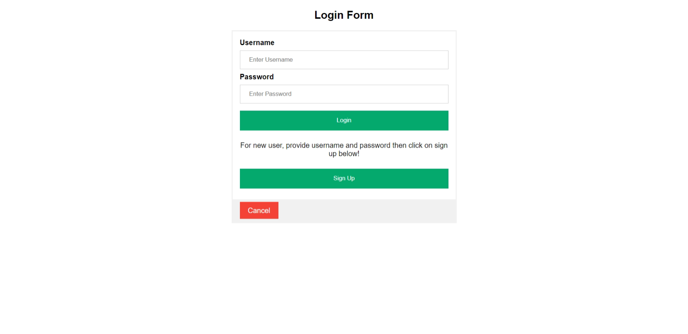

Figure 6: Admin Login Page

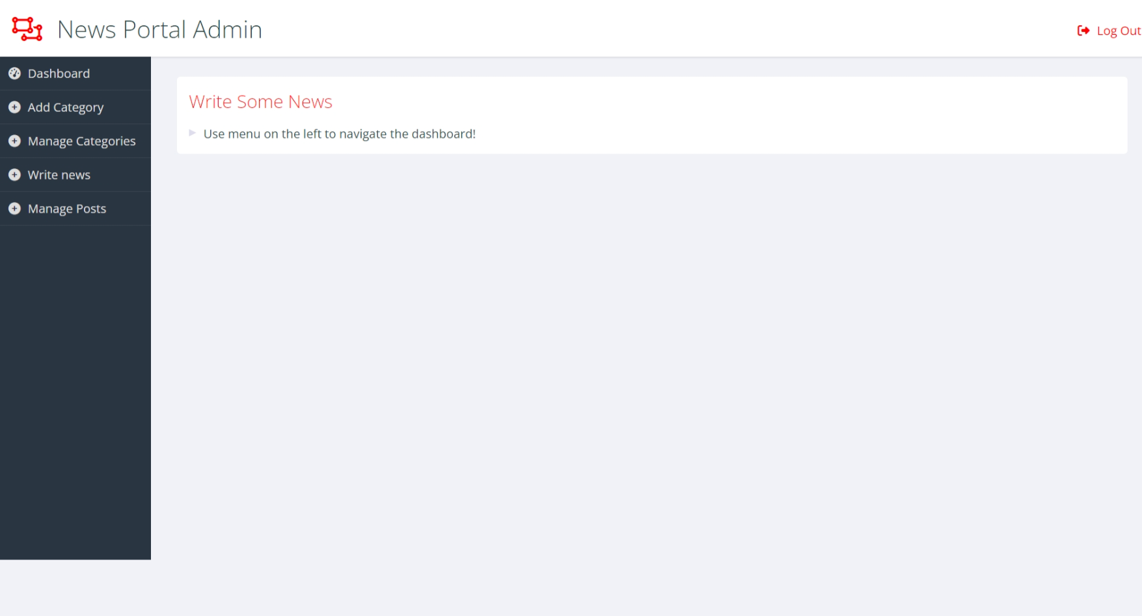

Figure 7: Admin Dashboard

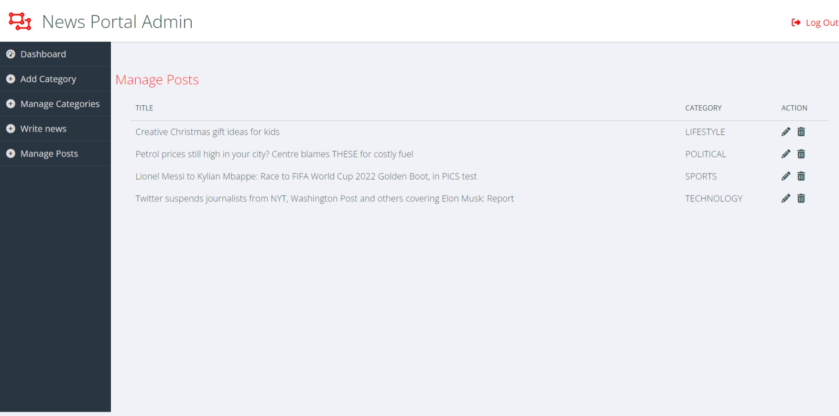

Figure 8: Admin Manage Posts Page

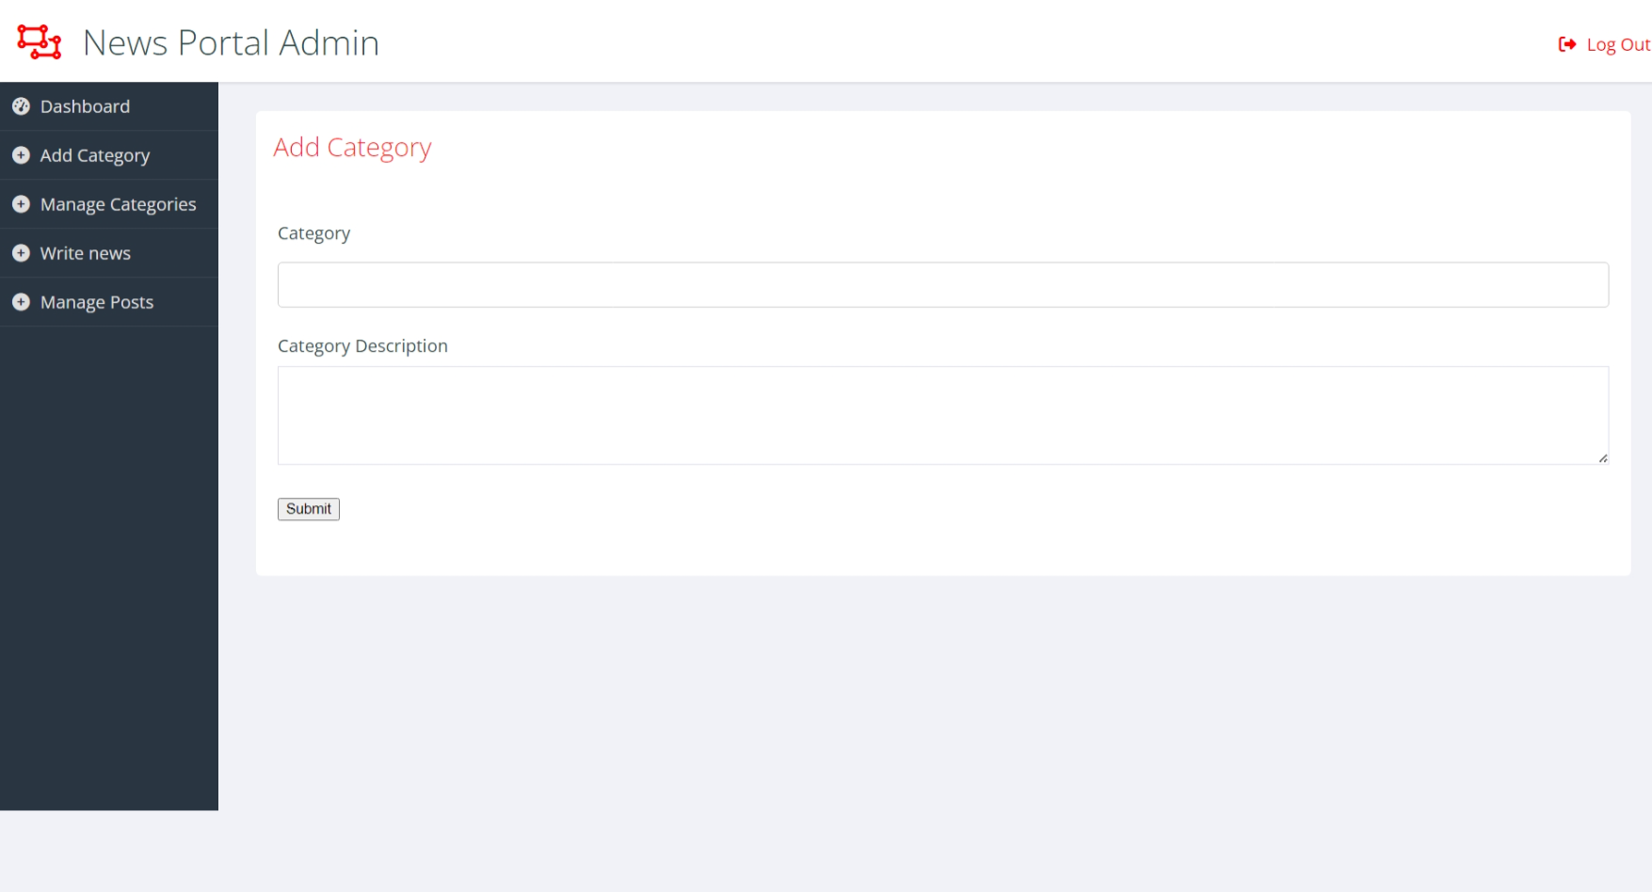

Figure 9: Add Category page

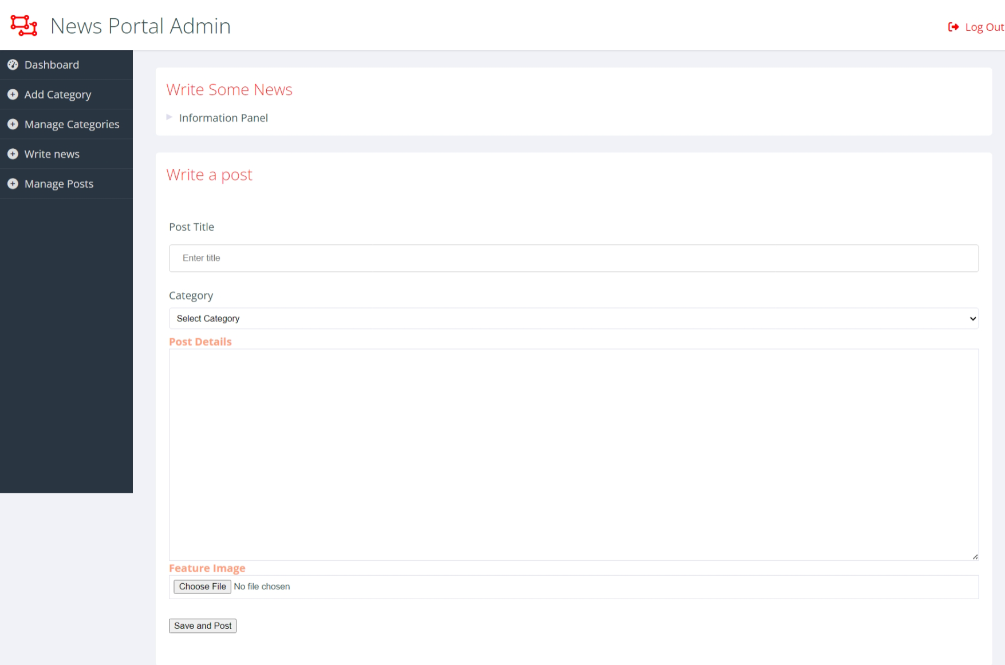

Figure 10: Add New post page

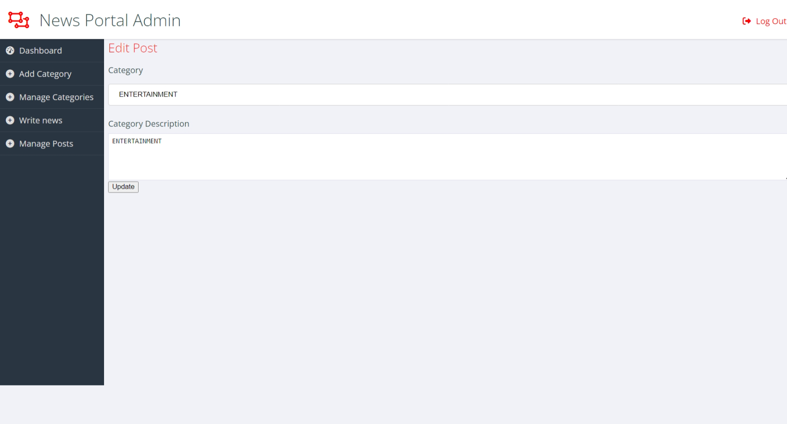

Figure 11: Category Edit page

# References

*Drudge Report.* (2001). Retrieved from Library of Congress: https://www.loc.gov/item/lcwaN0010145/

*Feasibility Study*. (2023, 08 25). Retrieved from Investopedia: https://www.investopedia.com/terms/f/feasibility-study.asp

*Functional & Non-Functional Requirement*. (2023, 08 25). Retrieved from Reqtest: https://reqtest.com/requirements-blog/understanding-the-difference-between-functional-and-non-functional-requirements/

*History of Yahoo!* (2023). Retrieved from Wikipedia: https://en.wikipedia.org/wiki/History_of_Yahoo!

*Software Prototype Model*. (2023, 08 25). Retrieved from TutorialPoint: https://www.tutorialspoint.com/sdlc/sdlc_software_prototyping.htm

*Test Cases*. (2023, 08 25). Retrieved from Software Testing Help: https://www.softwaretestinghelp.com/sample-test-cases-testing-web-desktop-applications/

*UML-diagram*. (2023, 08 25). Retrieved from Geeks for Green: https://www.geeksforgeeks.org/unified-modeling-language-uml-introduction/

Zhou, J. (2003). A History of Web Portals and Their Development in Libraries. *Information Technology and Libraries* , 119-128.